|  |
| --- |
|  |

**LOGO**

*CARE GROUP*

|  |  |  |  |
| --- | --- | --- | --- |
| SUPERVISOR | | SIR MUHAMMAD KHAILD | |
| BATCH | | 2112C1 | |
| GROUP | | D | |
| SERIAL NO | ENROLLMENT NUMBER | | STUDENT NAME |
| * 1 | **1348337** | | **FAIQA RASHID** |
| * 2 | 1346648 | | **ZAIN UD DIN** |
| * 3 | **1347742** | | **ZARLISH MUHAMMAD IQBAL** |

**ACKNOWLEDGEMENT**

**We would like to express our special thanks to our teacher (SirKhalid) as well as our institute (Aptech) who gave us golden opportunity to do this wonderful project on this topic (Care Group),which also helped us a lot of research and we came to know about so many new things we are thankful to them. Secondly, we would also like to thank our coordinator (Miss Maha) and friends who have helped us a lot in finalizing this project within the limited time frame.**

**INTRODUCTION**

**Care group is medical health care website where people in different cities can find doctors and online make appointments for their several pains and issues. Patient data will be confidential and the details of patient will only see admin or patient. After making online appointment the admin , doctor and patient receive the confirmation email by Care Group website or management.**

SITE MAP

**HOME**

**CONTACT**

**BLOG**

**ABOUT**

**APPOINTMENT**

**GALLERY**

**TEAM**

**SERVICES**

**FRONT END**

**HOME**

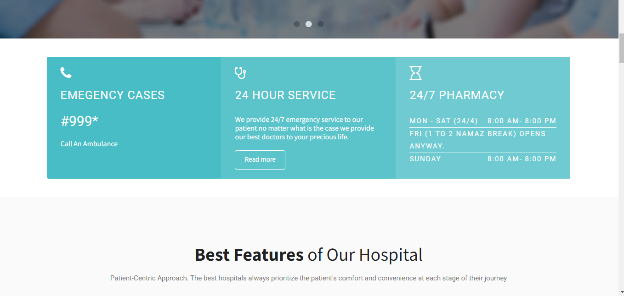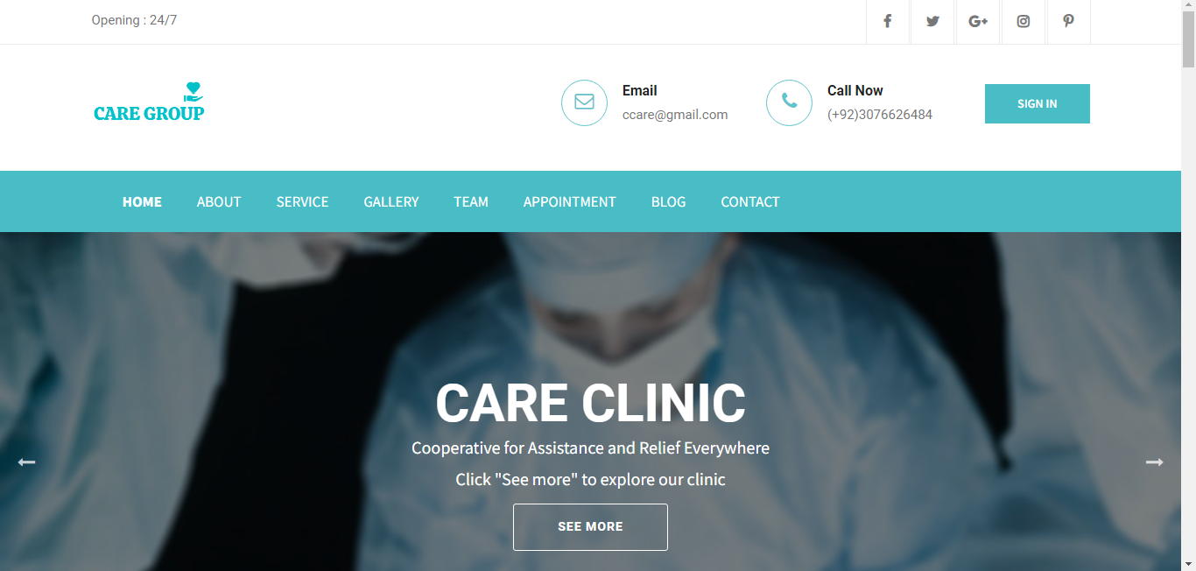

**FOOTER**

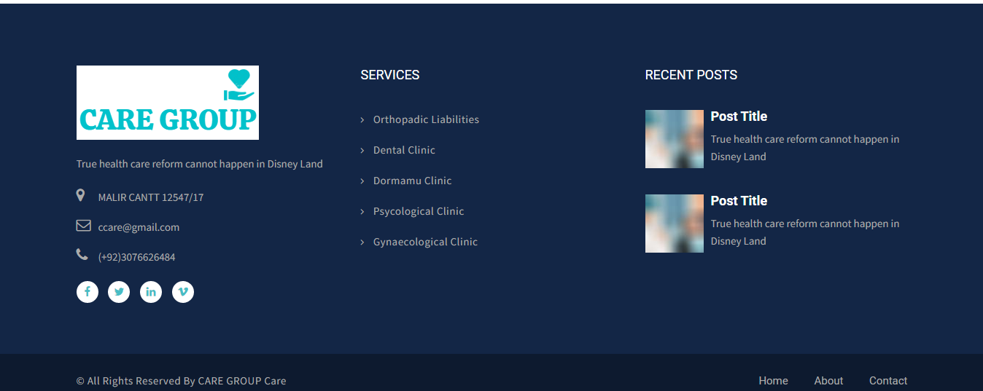

**ABOUT**

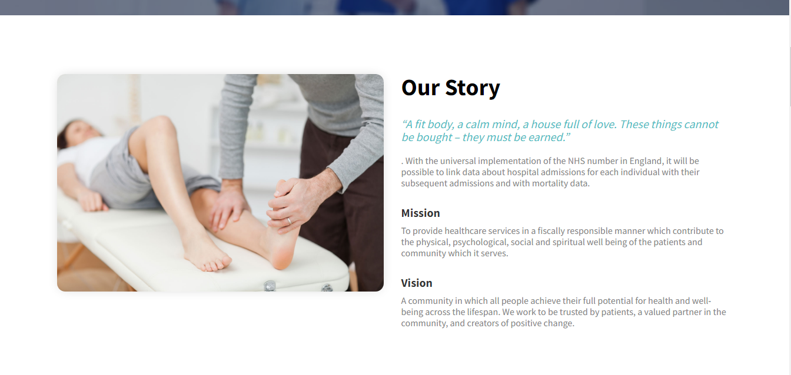

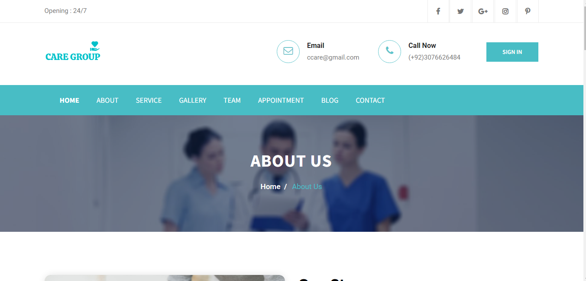

SERVICE

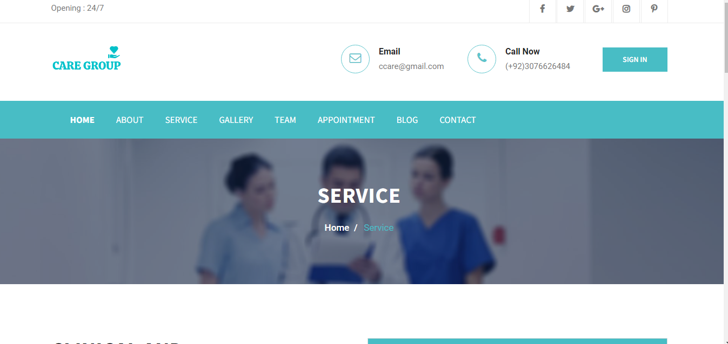

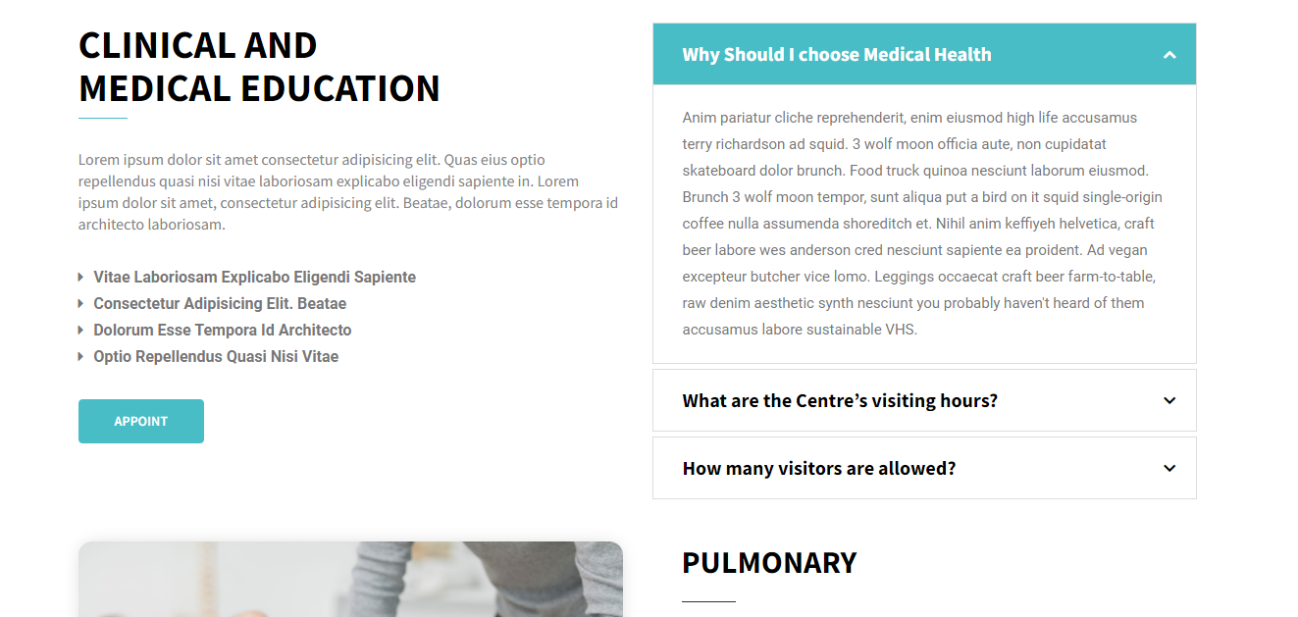

GALLERY

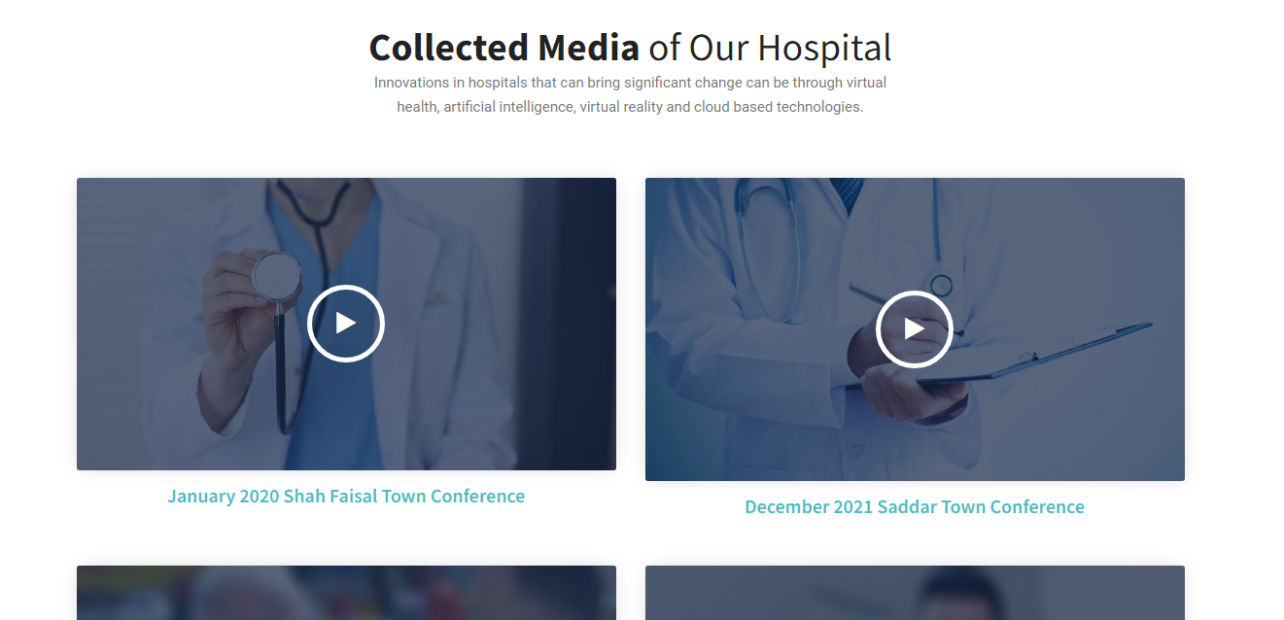

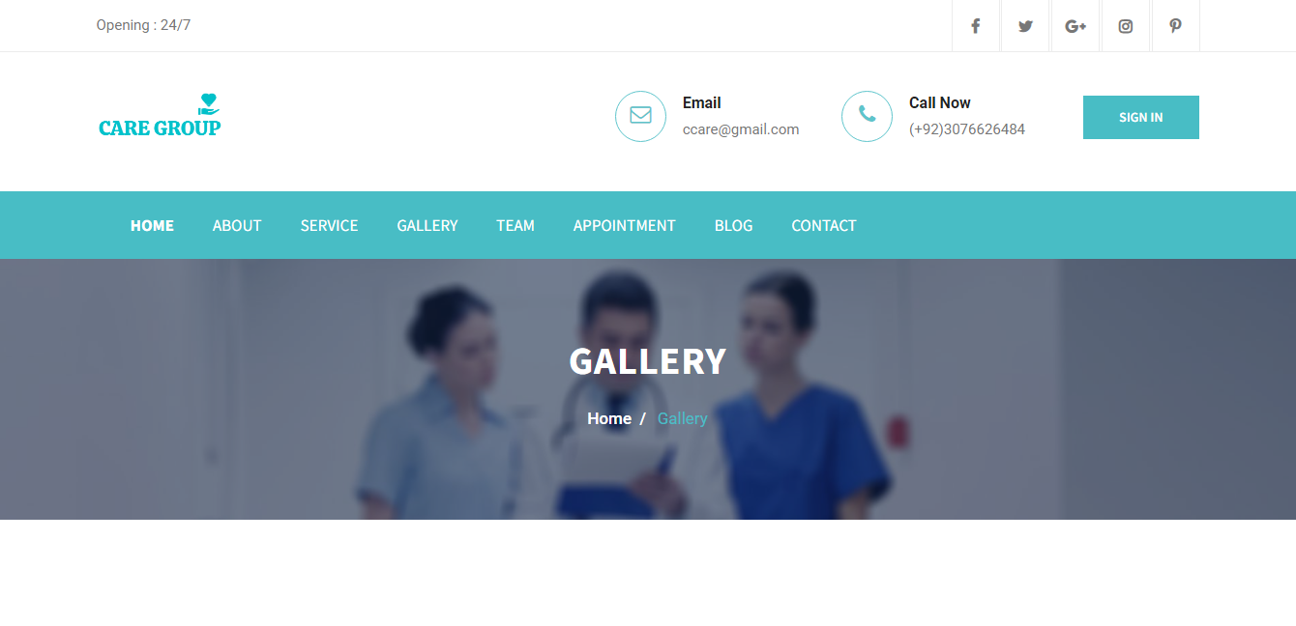

TEAM

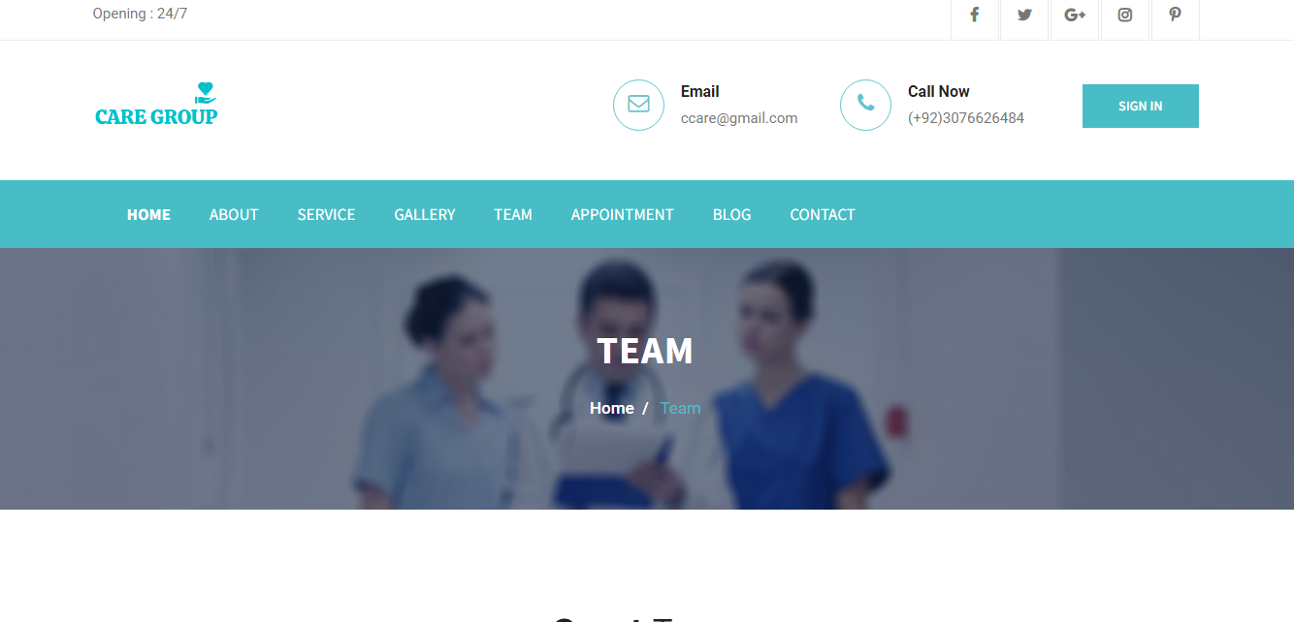

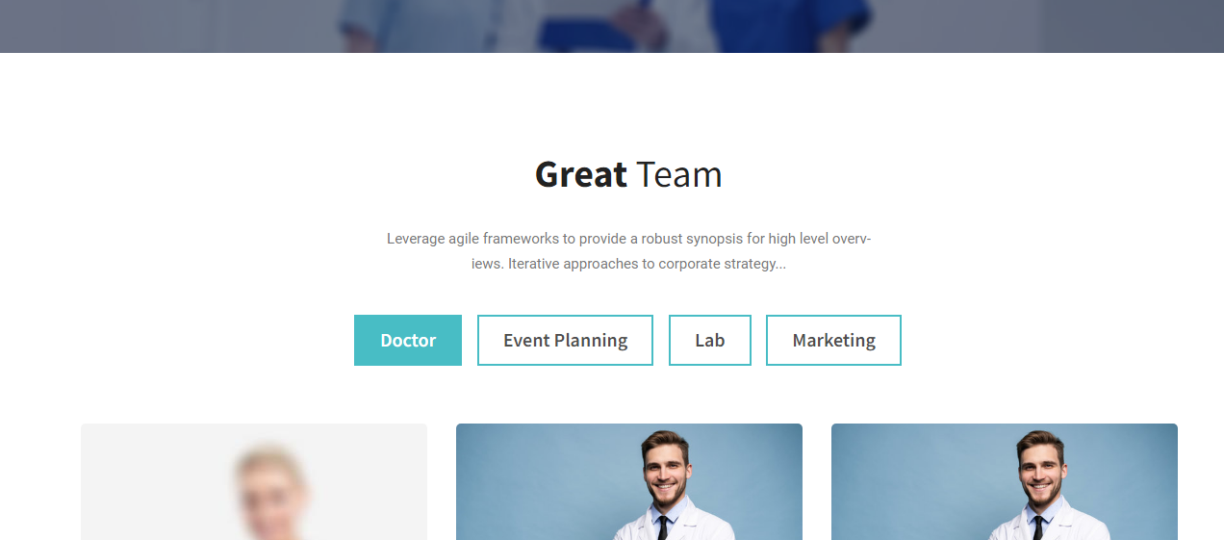

APPOINTMENT

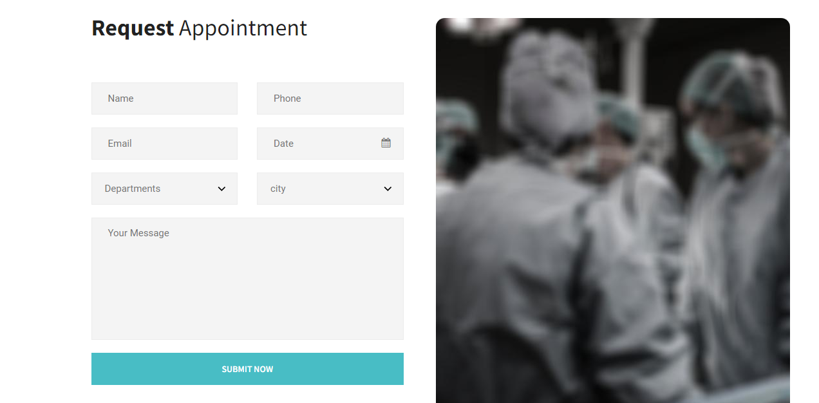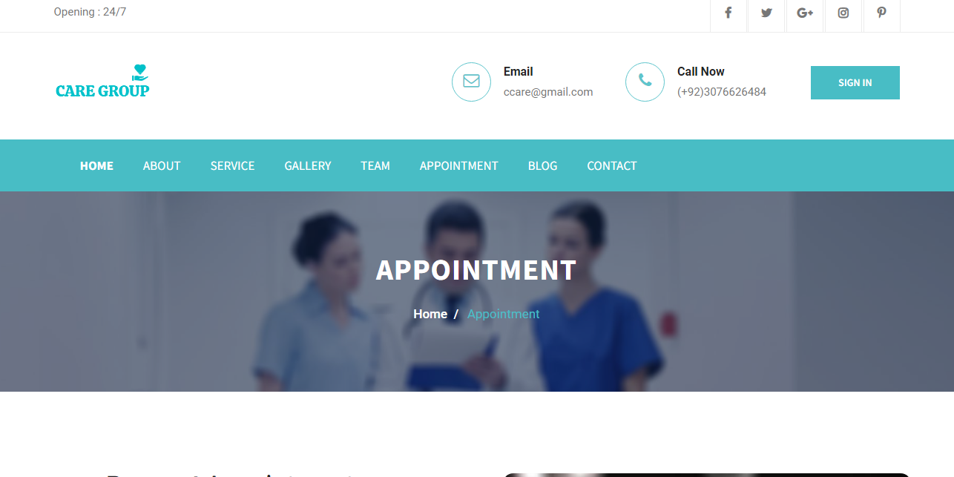

BLOG

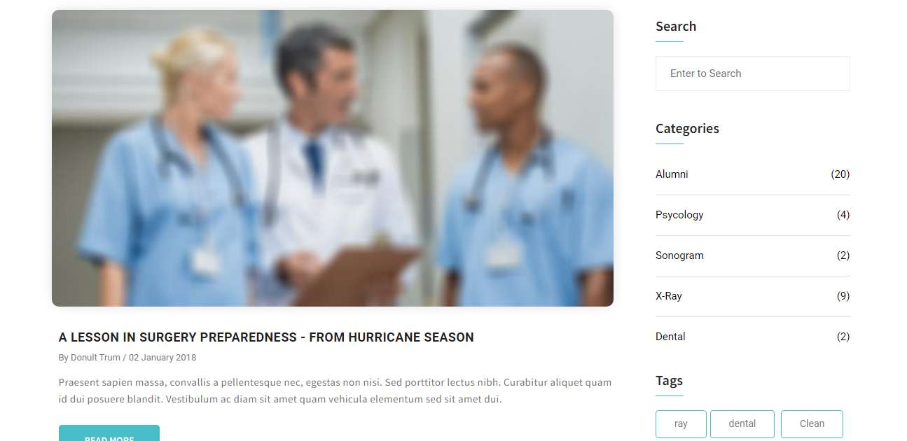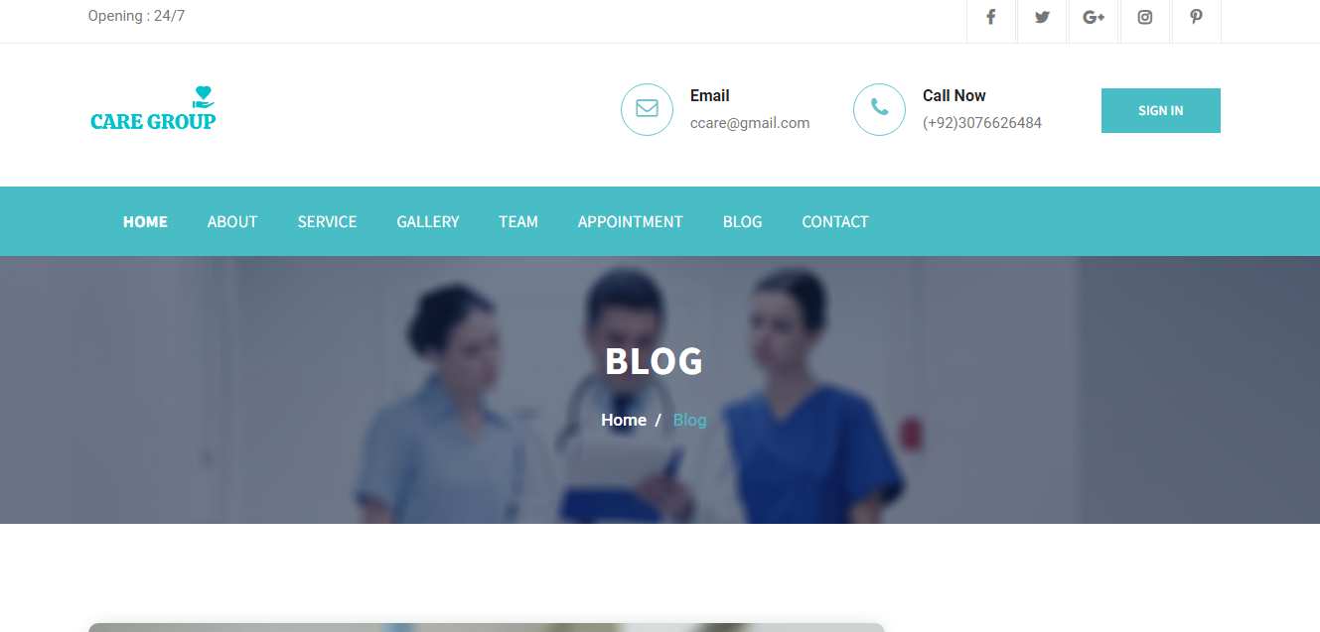

CONTACT

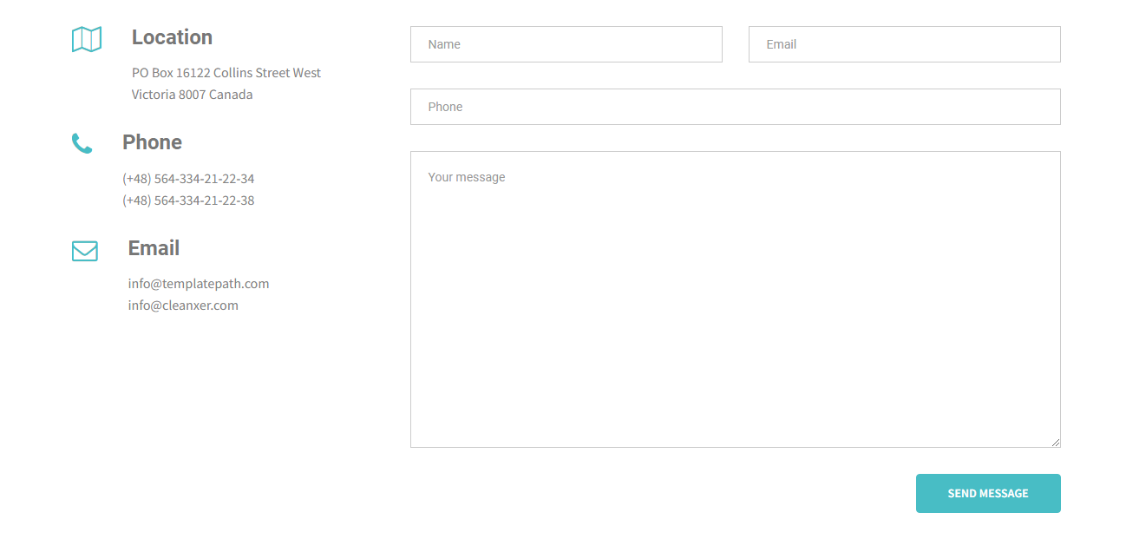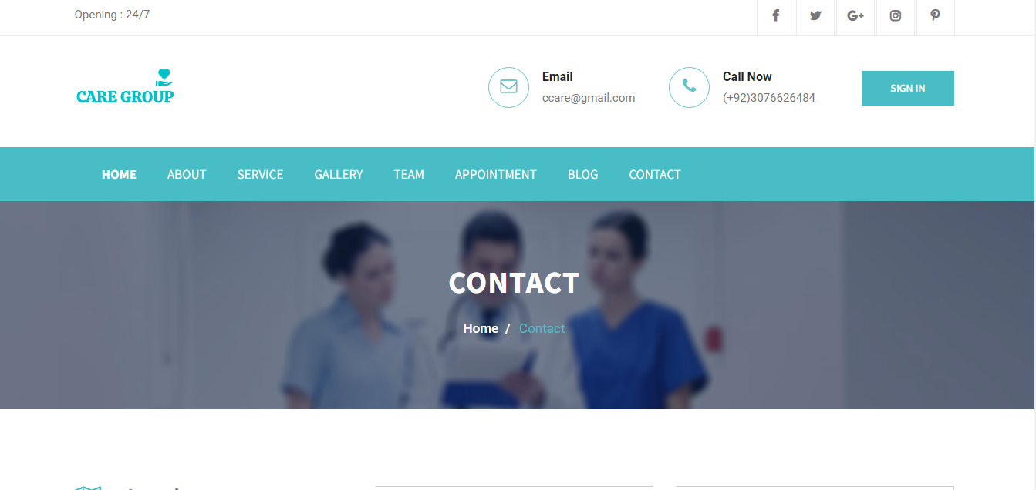

SIGN UP

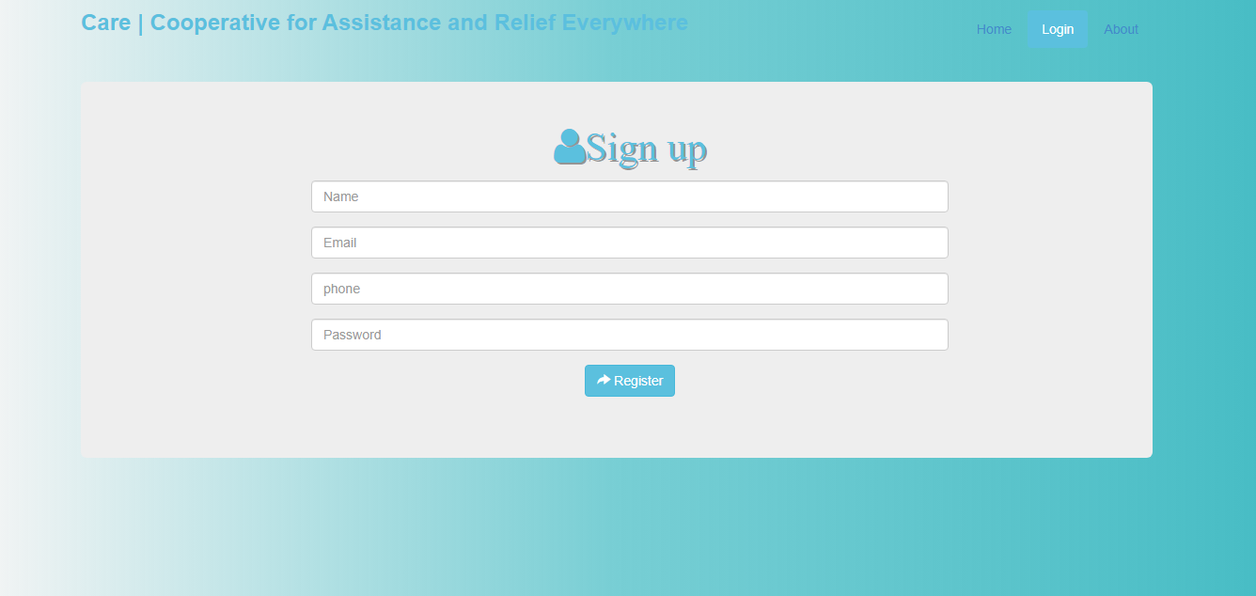

LOG IN

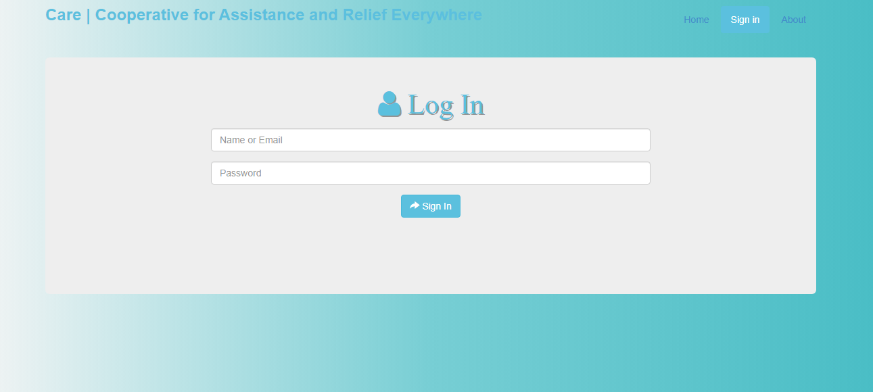

BACK END

DASHBOARD

ADMIN PANEL

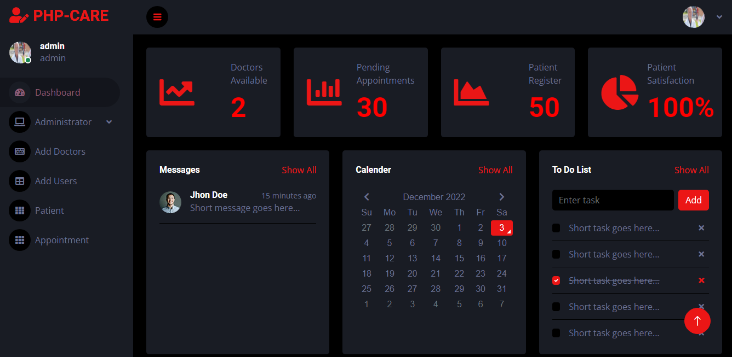

USER PANEL

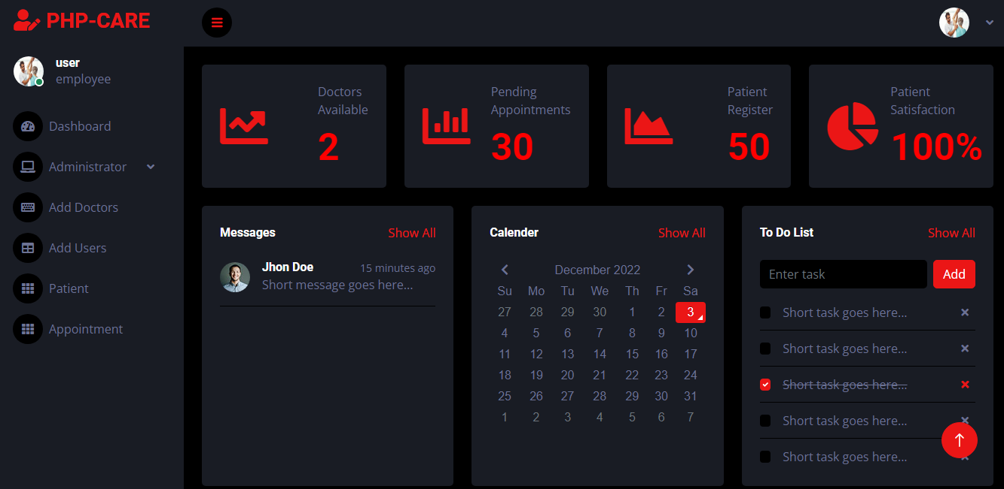

DOCTOR PANEL

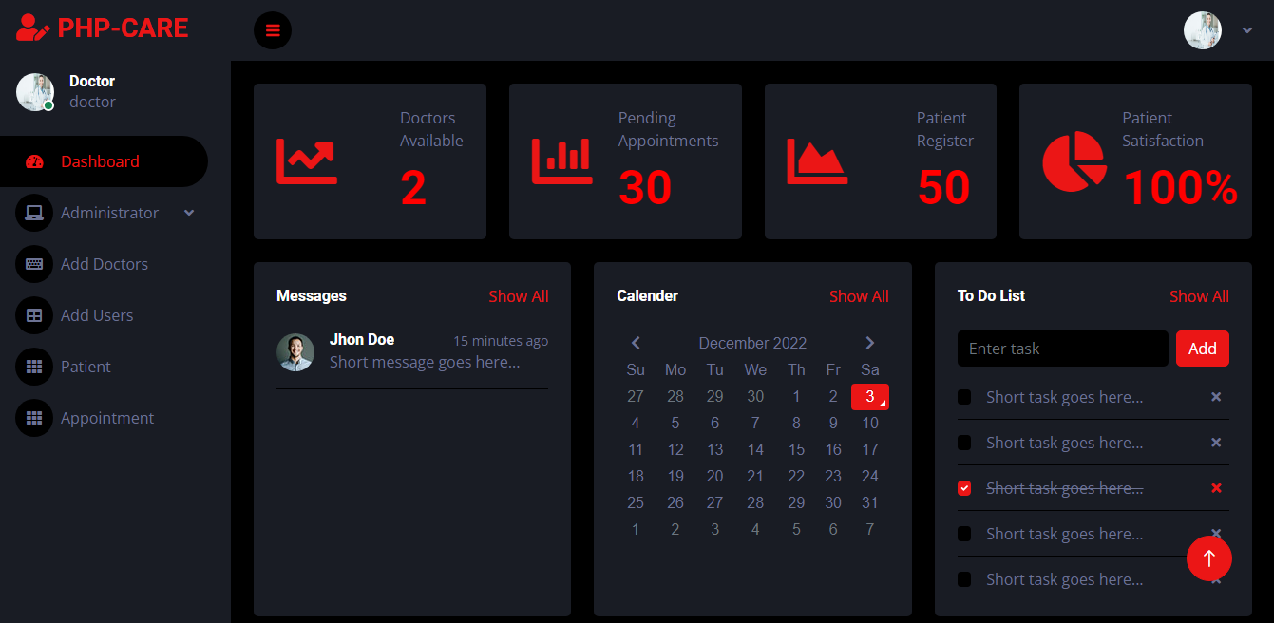

THANK YOU FOR READING THE USER GUIDE.